|  |  |
| --- | --- |
| University of Pittsburgh - Wikipedia  Computer vision  Assignment II | Quantiative Systems Neuroscience  Due February 6, 2024  Jessi Singh  *I collaborated on this assignment for part 2 gabor image plot and for part 1’s input matrix with Ian Buscay.* |

PART 1

Step A

Colorbar

***Figure 1.*** *In data collected involving visual perception, neural activity was recorded while an animal was shown a visual input of a light. Figure 1 demonstrates the Mach Bands which is a phenomenon in which perceived contrasted occurs around the edges of where luminance or brightness ramps up. In the figure above, there are 2 vertical bars around 30 and 90, in shade differences can be seen. The first bar is lighter than its surrounding and the second is also lighter. This illusion creates a gradient in the figure above. It represents how retinal ganglion cells can create a similar illusion through detection of brightness and contrast. which vertical bars, seemingly brighter and darker than their surroundings, are illusions. This illustrates the retina’s response to changes in brightness which lead to detection of edges.*

Step B

**Figure 2.** *Figure 2 aligns with Figure 1’s detection of lightness “ramping up”. There is a fluctuation in brightness at 32 on the x-axis, where the brightness ramped up. We see that maximal brightness occurs around 90. In examining a horizontal slice, visualization occurs of a cross-sectional view of visual stimulus. Therefore, the brightness can be detected at specific vertical position. The retina is capable of doing some initial processing of data to detect the edges of object’s based on fluctuation of brightness, and this figure aligns with this idea by offering a visualization of some fluctuations.*

Step C

Colorbar

***Figure 3.*** *Figure 3 is the receptive field of a retinal ganglion cell. The color-bar, off to the right, ranges from white (brightest intensity at 500) to black (darkest or lowest intensity at -100). This color is of note as it indicates that the center (white) is brightest/lightest. The surround is darkest. This receptive field represents on-off nature. There are both excitatory and inhibitory regions in this model. White represents a excitatory center and Black/dark gray represents a dark surround. This retinal ganglion model is generated from taking the difference of two 2D Gaussians, so the formed receptive field is a spatial representation of the cell's responsiveness to light which is the visual stimuli presented to the animal. Excitatory center (white) is represented by a narrow Gaussian (Egaus), and overlapped with a broader Gaussian (Igaus, black) depicting the inhibitory surround of the cell. To generate this model, the overall connectivity strength was selected to be S=500.*

Step D

Colorbar

***Figure 4****. The figure above demonstrates the convolution of receptive field using the input image and function conv2. This is akin to the type of filtering and visual processing which occurs early in the retina. Here, convolution combines both the receptive field of a neuron with the input image to simulate how neurons respond to light intensity. In the retina, there will be ganglion cells with receptive fields that will be able to detect edges or changes in light intensity. Convolution then, is like an image processing filter which functions to replicate the job of the receptive field "viewing" the input through a specific lens. Figure in the figure above, there are 2 vertical bars around 30 and 90, in shade differences can be seen. The first bar is lighter than its surrounding and the second is also lighter. This illusion creates a gradient in the figure above. It represents how retinal ganglion cells can create a similar illusion through detection of brightness and contrast. which vertical bars, seemingly brighter and darker than their surroundings, are illusions. This illustrates the retina’s response to changes in brightness which lead to detection of edges.*

**Figure 5.** *Figure 5 shows the output after convolution of the visual field. There appears to be activity of note around 32 and 90. This horizontal slice indicates that there are places where changes in brightness or darkness can be detected by the retina. The two horizontal slices which are slices at which the output plateau’s help to provide insights into how neural responses vary horizontally.*

*The figures 4 and 5, generated for step D, together help elucidate the Mach Band Illusion basis. The plots show that there is a change in perception where there is a shift in brightness/darkness which helps to detect edges of an object. This happens when tehre is a change in intensity of light. To generate these plots, this was computationally modeled in Matlab, where the visual stimulus, light, was shown to an animal in a manner where there was a linear increase. In the figure above, that is shown by a gradient above. The gradient relates to a retinal ganglion cell’s receptive field. Convolution function was applied to this because it helps to really make stark the difference in perceived contrast, so there is the illusion of these vertical columns, or bands, which disrupt the gradient. For clarity, this refers to the areas that have the arrows pointing to them on Figure 4.*

*Now that the Mach Band illusion has been identified, it is important ot understand the retina’s role in taking in information and beginning to process it. This level of detection is clearly important for edge detection which happens at the retina level through a process referred to as lateral inhibition. Lateral inhibition is a process through which a neuron’s neighbors can help to inhibit activity of neighboring cells. Usually this is a process which happens laterally which means that one receptor or neuron can affect others near it to help, in this case, establish these dark/light edges and contrast perception in vision.*

PART 2

Step A, B,C,D _ gabor and gaussian

**Gabor functions**

***Figure 6.*** *The Gabor function resembles the activity of cells in visual cortex (V1). Literature suggests that V1 cells are known to respond selectively to bars of light at specific orientations and scales. The Gabor function models this computationally as it a two -dimensional Gaussian modulated by a sine wave. In Figure 6a, the Gabor function parameters are defined by an orientation (OR) and a spatial frequency (SF). The figure illustrates the output of a Gabor function applied to an image. It is like the Gabor function is a filter that can detect edges or textures. The output reveals the enhanced representation of these features. In the figure above, OR and SF parameters are manipulated.. In this manner, we can start to understand directionality and selectivity of the V1 cells in the brain.*

Step d,e,f

**Figure 7a*.*** *Figure 7a shows a rose (left) and convolved rose (right). The images are created of pixels, with x and y axis encoding position, horizontal or vertical, of the pixels. To generate the convolved image, the Gabor function was convolved with the ‘rose.jpg' image. The Gabor function helps to model the way that cells in V1 respond to bars of light at specific orientation and scales. The orientation (OR) and spatial frequency (SF) help to accomplish this. The OR is an orientation parameter, so it allows for the function to be runed for specific orientations/bars/edges. On the other hand, V1 cells are also sensitive to specific frequencies so that means that certain patterns may cause increased activity or response. The Gabor function mimics this through the parameter for frequency parameter (SF), which manipulates the sine wave and can tune to detect certain frequencies. While there are other aspects of the Gabor function that mimic V1, the convoluted rose clearly highlights how, similar to V1 cells, there can be orientation and spatial sensitivity at the level of the visual cortex. The convolved rose was generated at OR = pi/2 radians and SF = .05 spatial frequency.*

**Figure 7b*.*** *Figure 7b shows a rose (left) and convolved rose (right). The images are created of pixels, with x and y axis encoding position, horizontal or vertical, of the pixels. To generate the convolved image, the Gabor function was convolved with the ‘rose.jpg' image. The Gabor function helps to model the way that cells in V1 respond to bars of light at specific orientation and scales. The orientation (OR) and spatial frequency (SF) help to accomplish this. The OR is an orientation parameter, so it allows for the function to be runed for specific orientations/bars/edges. The convolved rose was generated at OR = pi/4 radians and SF = .1 spatial frequency.*

**Figure 7c*.*** *Figure 7c shows a rose (left) and convolved rose (right). The images are created of pixels, with x and y axis encoding position, horizontal or vertical, of the pixels. To generate the convolved image, the Gabor function was convolved with the ‘rose.jpg' image. The Gabor function helps to model the way that cells in V1 respond to bars of light at specific orientation and scales. The orientation (OR) and spatial frequency (SF) help to accomplish this. The OR is an orientation parameter, so it allows for the function to be runed for specific orientations/bars/edges. The convolved rose was generated at OR = pi/4 radians and SF = .05 spatial frequency. When the SF is .05, as opposed to .1, we see more edges form in the convolved rose. This suggests that there may be edge detection which is directionally selective in V1 cortex. When the OR is the same (pi/4) then there are more lines which show up on a diagonal than when we look at pi/2. This also suggests directionally selectivity is occurring.*

**Figure 7d*.*** *Figure 7d shows a rose (left) and convolved rose (right). The images are created of pixels, with x and y axis encoding position, horizontal or vertical, of the pixels. To generate the convolved image, the Gabor function was convolved with the ‘rose.jpg' image. The Gabor function helps to model the way that cells in V1 respond to bars of light at specific orientation and scales. The orientation (OR) and spatial frequency (SF) help to accomplish this. The OR is an orientation parameter, so it allows for the function to be runed for specific orientations/bars/edges. The convolved rose was generated at OR = pi/2 radians and SF = .1 spatial frequency. When SF is .1 as opposed to .05, we see white or gray against dark gray which suggests that in addition to edge detection, there may be depth/contrast detection in V1 cells as well. The pi/2 OR convolved roses have lines which appear more horizontal which suggests directional selectivity, as well.*

Step 3

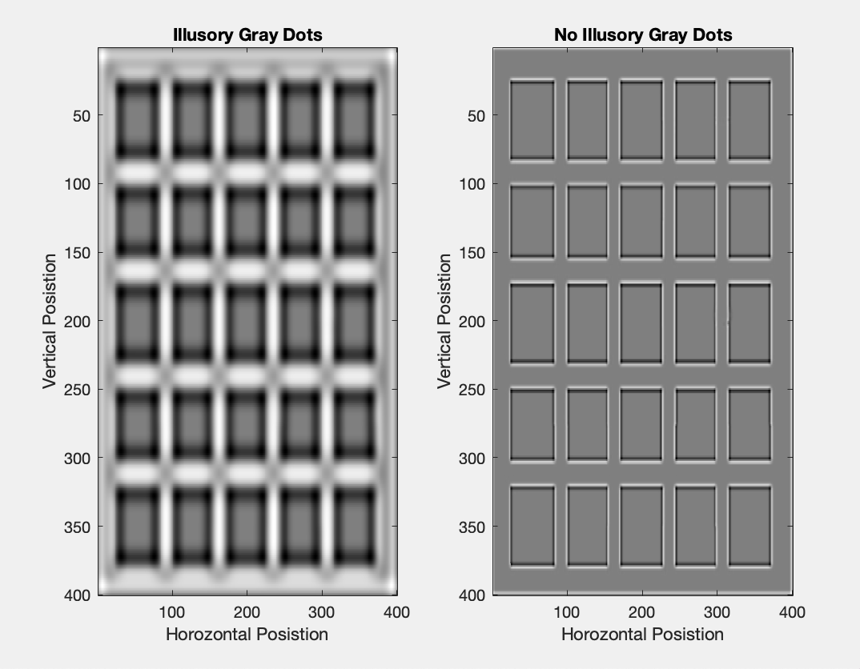

**Figure 9.** *The figure above a stimulated visual field using the "retina" function after changing parameters. The illusory grey spots, visible in the periphery of a person’s vision show the behavior of receptive fields. The reason for the bright spots dissipating is due to lateral inhibition. Certain ganglion cells respond to direction and others to light. Additionally, the receptive field of cells plays a role in the visual stimuli detected. Through manipulation of the rf_size_fraction variable, which represents the size of the visual field as a fraction of the image size, the sensitivity of a neural receptive field was modeled. Smaller values are smaller receptive fields with more resolution, but larger values would be larger receptive fields. Smaller receptive fields can detect more detail but larger can see bigger pictures and less resolution.* In the image on the left, the size fraction variable was kept smaller, at .1 but on the right, it was increased to .4. This can be compared to the original image for the Hgrid which is displayed below.